SECR2043 OPERATING SYSTEMS

Name | : JOANNE CHING YIN XUAN | Marks
Student ID | : A23CS0227
Section | : 3

This lab assessment is designed to test your understanding and skills on some basic concepts and tools related to operating system. Please follow the instructions carefully and submit your answers in this word document and rename the file as os-lab-assessment01-studentname-matricno.docx.

ACTIVITY 1 : | BASIC LINUX COMMANDS

In this activity, you will practice some basic Linux commands that are useful for operating system tasks. For each question, write down the command you used and the output you got in your answer file. If the command does not produce any output, write "No output" instead.

1. | Display your current working directory.
 | Command | Output
 | pwd | 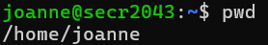
2. | List all the files and directories in your home directory, including hidden ones.
 | Command | Output
 | ls -a ~`
3. | Create a new directory named "os_lab" in your home directory.
 | Command | Output
 | mkdir os_lab | 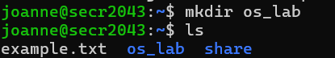
4. | Change your current working directory to "os_lab".
 | Command | Output
 | cd os_lab  pwd | 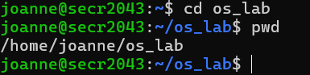
5. | Create a new file named "hello.txt" in "os_lab" and write "Hello, world!" in it.
 | Command | Output
 | touch hello.txt  echo “Hello,world!” > hello.txt | 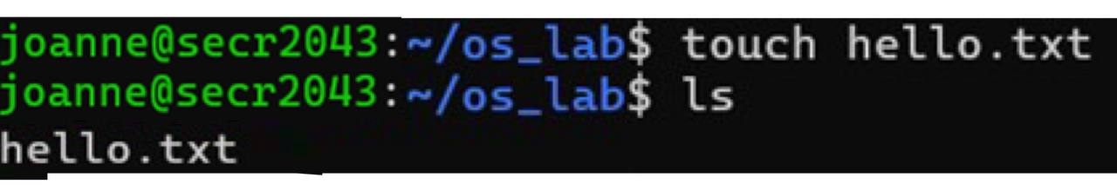

6. | Display the content of "hello.txt".
 | Command | Output
 | cat hello.txt | 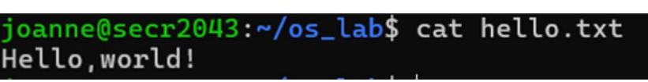
7. | Copy "hello.txt" to another file named "hello_copy.txt" in the same directory.
 | Command | Output
 | cp hello.txt hello_copy.txt | 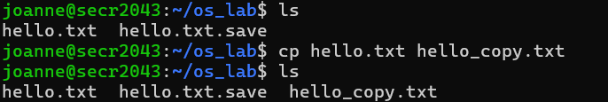
8. | Rename "hello_copy.txt" to "hello_bak.txt".
 | Command | Output
 | mv hello_copy.txt hello_bak.txt | 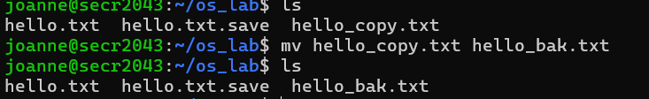
9. | Delete "hello.txt".
 | Command | Output
 | rm hello.txt | 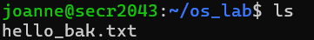
10. | Display your home directory with additional information, together with subdirectories contents.
 | Command | Output
 | ls -R /home | 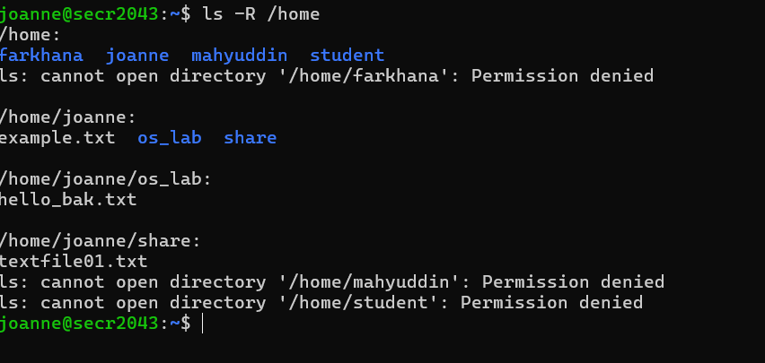
 | Total Mark:

ACTIVITY 2 : | Text File Manipulation

In this activity, you will practice some commands to create and manipulate text files using echo, cat and touch.

For each question, write down the command and the output (if any) in the answer sheet.

1. | Create an empty file named "hello.txt" in the current working directory.
 | Command | Output
 | touch hello.txt | 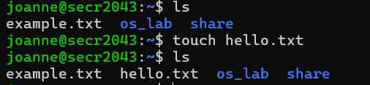
2. | Write the text "Hello World" to "hello.txt" using echo.
 | Command | Output
 | echo “Hello World” > hello.txt
3. | Append the text "This is a test" to "hello.txt" using echo.
 | Command | Output
 | echo “This is a test” >> hello.txt
4. | Display the contents of "hello.txt" using cat.
 | Command | Output
 | cat hello.txt | 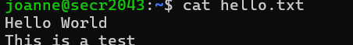
5. | Create another file named "bye.txt" with the text "Goodbye World" using echo.
 | Command | Output
touch bye.txt
echo “Goodbye World” > bye.txt
6. | Concatenate the contents of "hello.txt" and "bye.txt" and display them using cat.
 | Command | Output
 | cat hello.txt bye.txt | 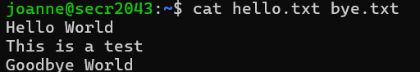
7. | Concatenate the contents of "hello.txt" and "bye.txt" and write them to a new file named "greeting.txt" using cat.
 | Command | Output
 | cat hello.txt bye.txt > greeting.txt

8. | Display the contents of "greeting.txt" using cat.
 | Command | Output
 | cat greeting.txt | 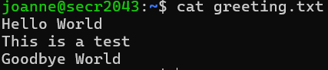
9. | Edit the file "greeting.txt" using Nano and change the word "World" to your name in both lines.
 | Command | Output
 | nano greeting.txt | 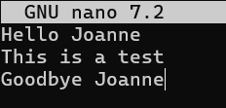
10. | Display the modified contents of "greeting.txt" using cat.
 | Command | Output
 | cat greeting.txt | 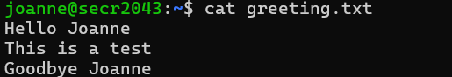
 | Total Mark:

ACTIVITY 3 : | WRITE, COMPILE AND RUN C PROGRAM

In this activity, you will practice how to write, compile and run a simple C program using gcc. For each question, write down the command and the output (if any) in the answer sheet.

1. | Write a C program that prints "Hello World" to the standard output using Nano and save it as "hello.c".
 | Command | Output
 | nano hello.c | 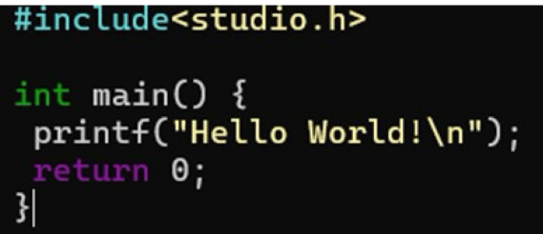
2. | Compile the program "hello.c" using gcc and generate an executable file named "hello".
 | Command | Output
 | gcc hello.c -o hello
3. | Run the executable file "hello" and display its output.
 | Command | Output
 | ./hello | 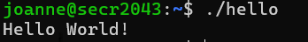
4. | Write a C program that takes two integers as command line arguments and prints their sum to the standard output using Nano and save it as "sum.c".
 | Command | Output
 | nano sum.c | 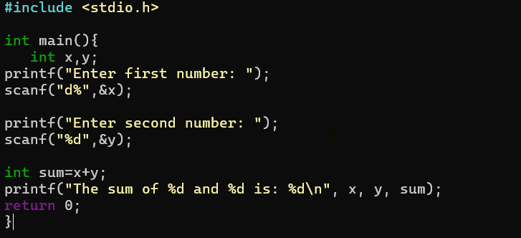
5. | Compile the program "sum.c" using gcc and generate an executable file named "sum".
 | Command | Output
 | gcc sum.c -o sum | 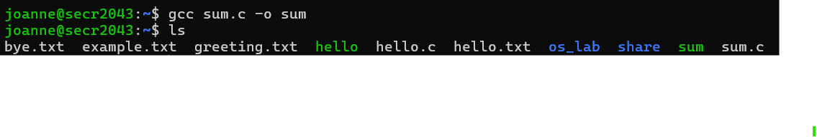
6. | Run the executable file "sum" with 10 and 20 as arguments and display its output.
 | Command | Output
 | ./sum | 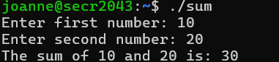
7. | Run the executable file "sum" with -5 and 15 as arguments and display its output.
 | Command | Output
 | ./sum | 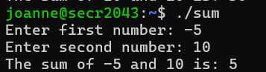

8. | Write a C program that reads a line of text from the standard input and prints it to the standard output using Nano and save it as "echo.c".
 | Command | Output
 | nano echo.c | 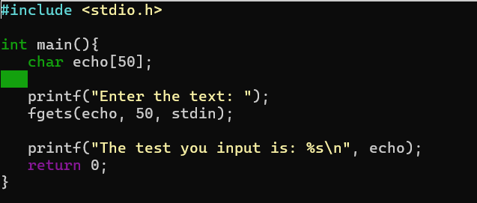
9. | Compile the program "echo.c" using gcc and generate an executable file named "echo".
 | Command | Output
 | gcc echo.c -o echo
10. | Run the executable file "echo", type "Hello World" as input and display its output.
 | Command | Output
 | ./echo | 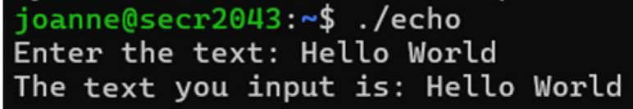
 | Total Mark:

